COT4501 HW 1

Study Group: Nicolas Petrakis, Nicholas miller, Tyler Metzger

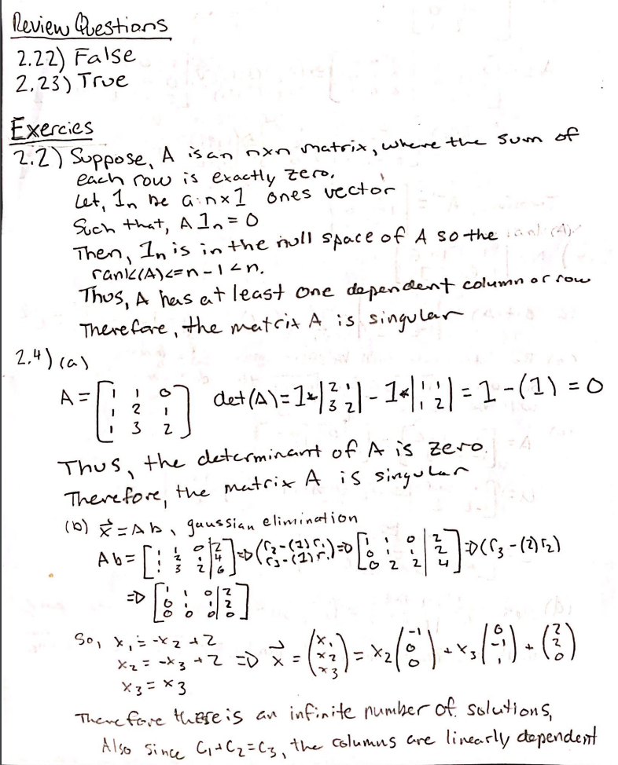

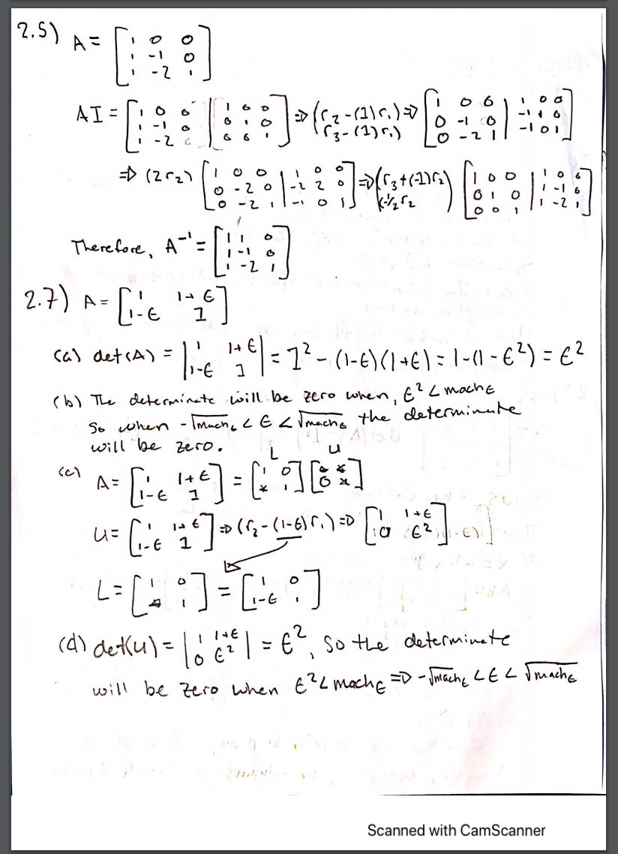

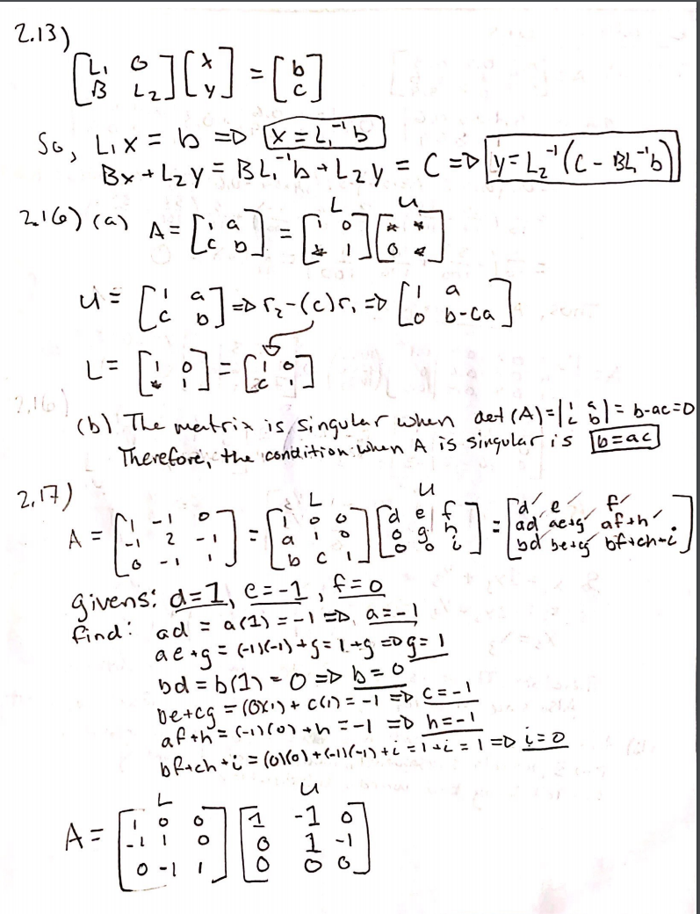

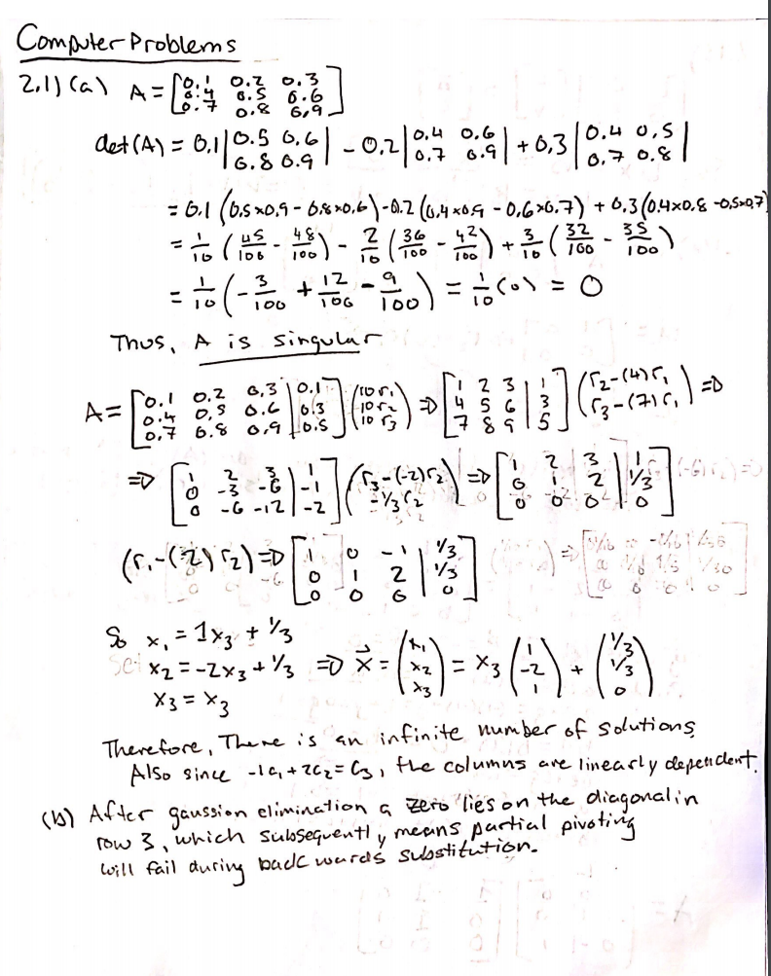

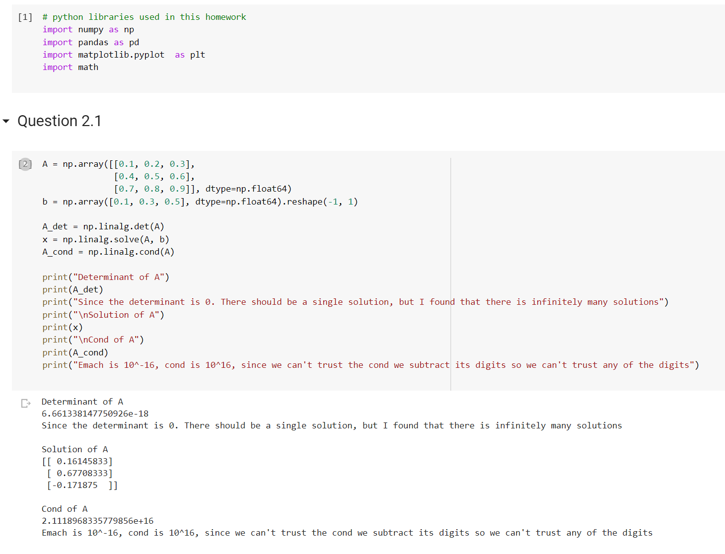

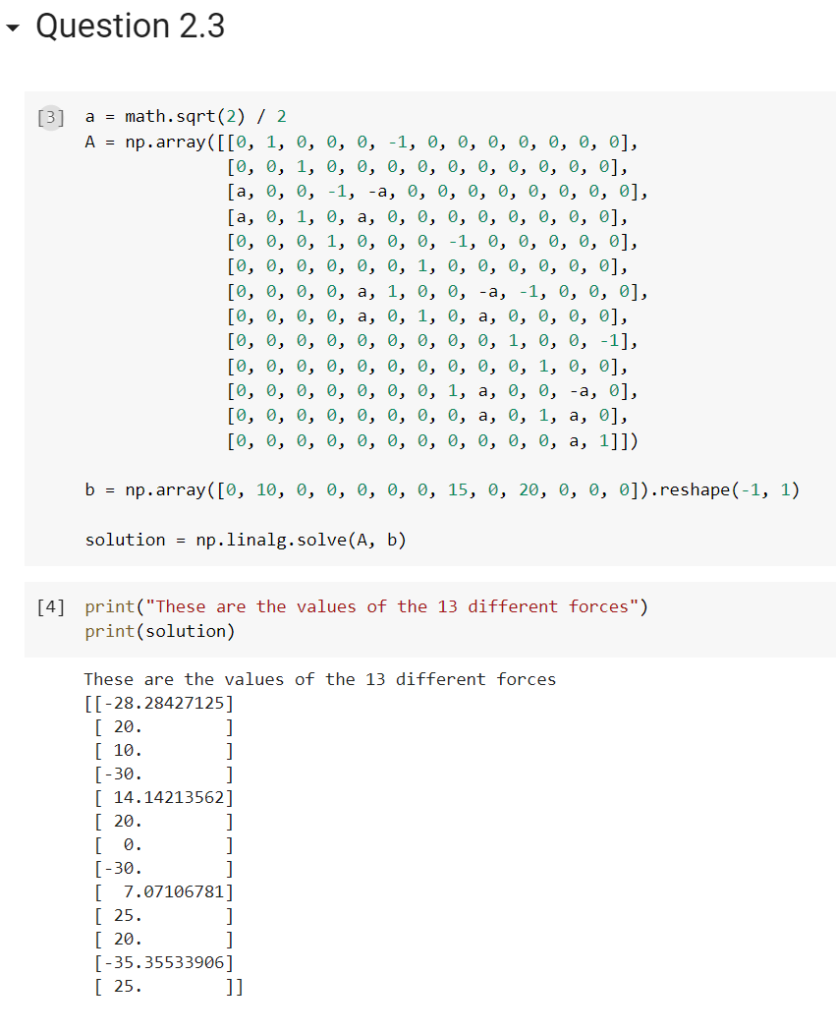

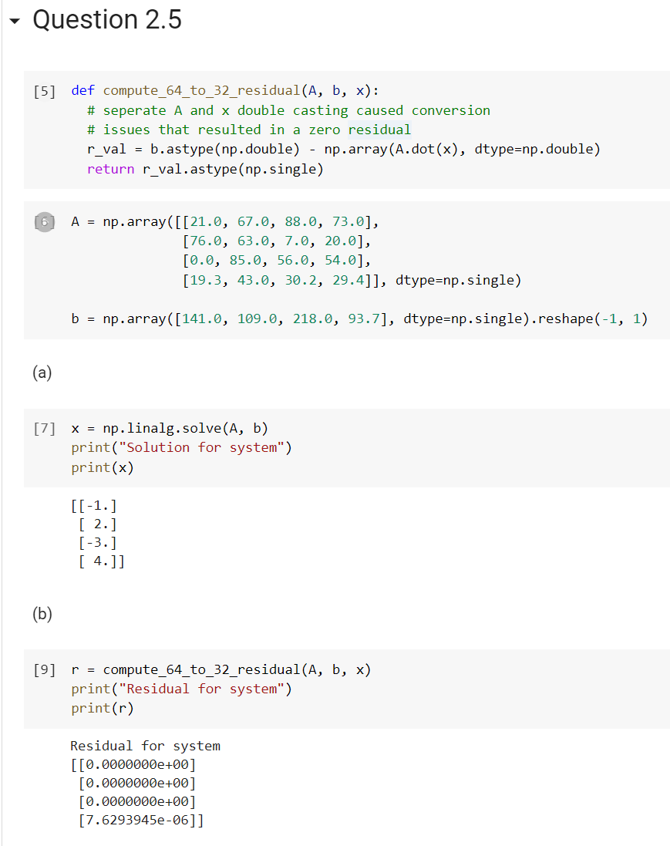

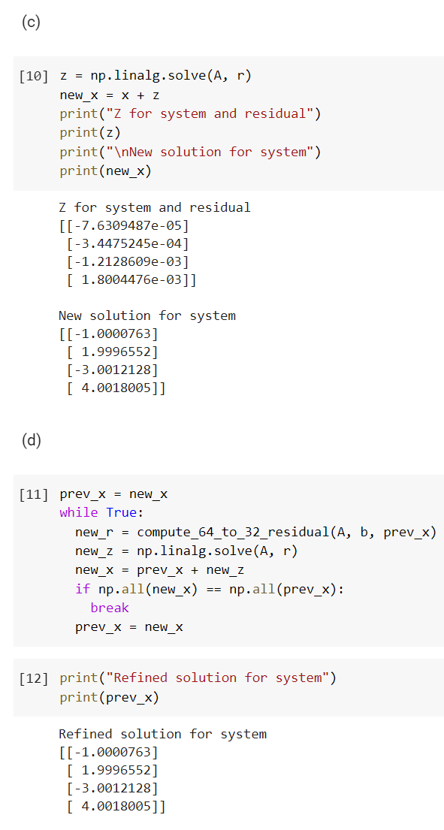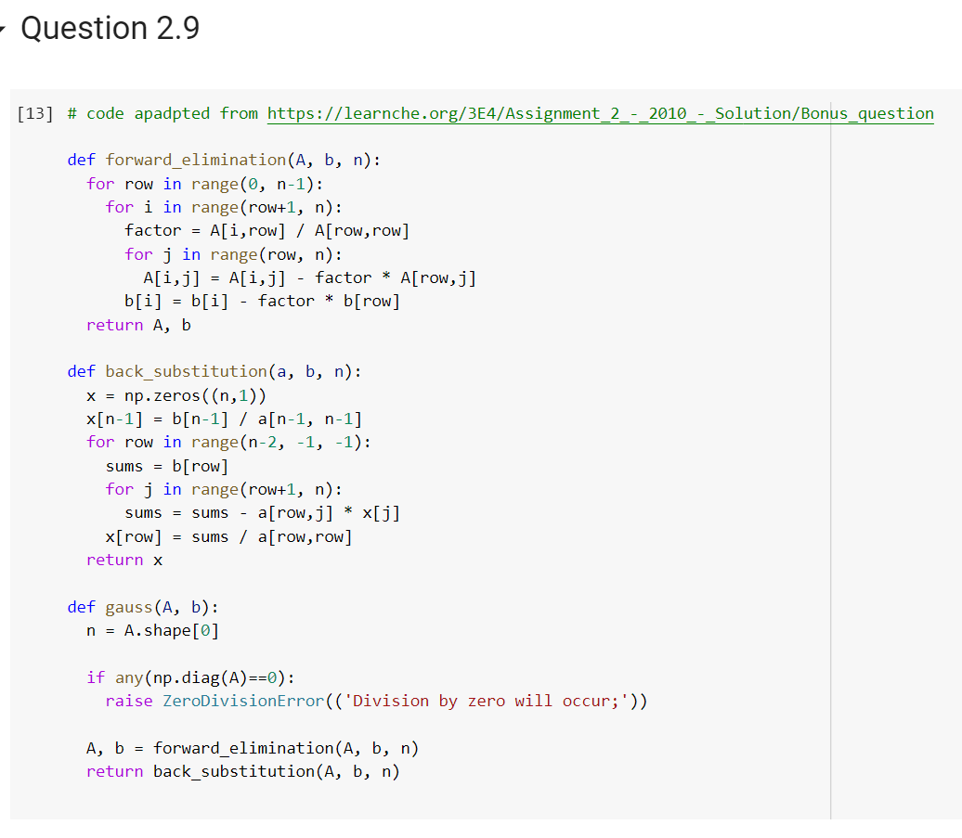

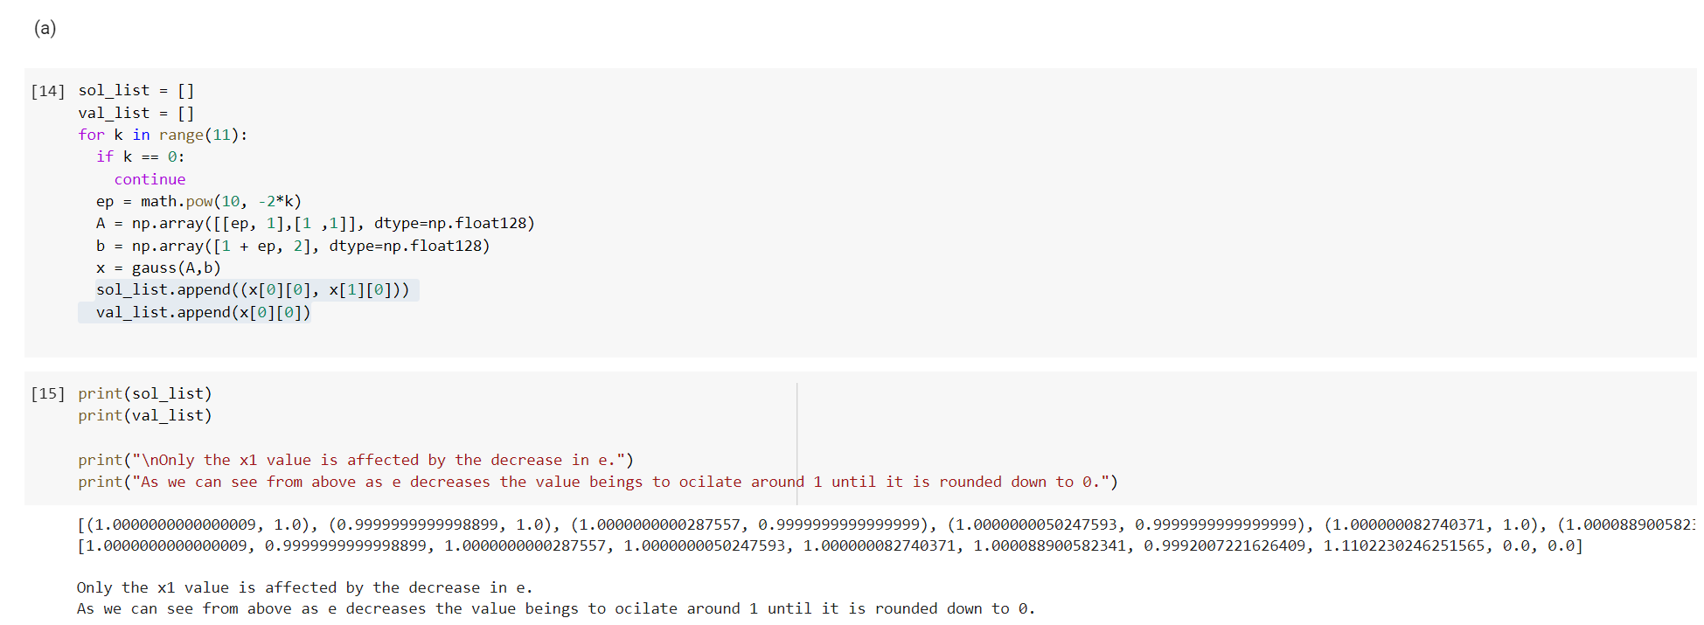

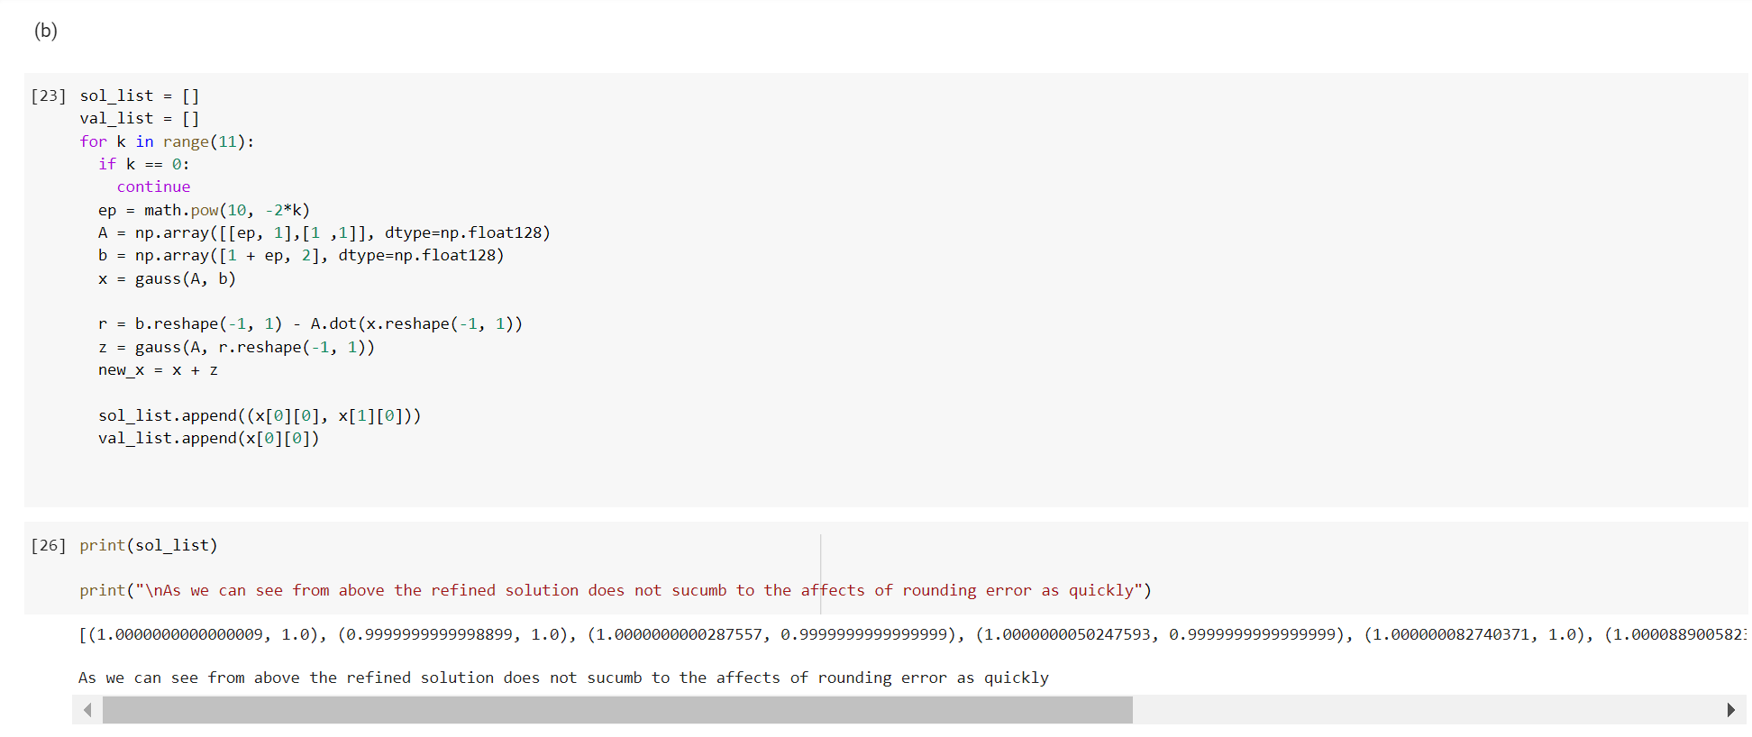

BONUS

1)

One very useful real life application of linear algebra is the computation of page rankings for web searches. Since the internet is just a web of different pages linking to others we can form a matrix of the web in the form of a graph, where an inlink is 1 and an outlink is -1. The dimension of this matrix will be the total number of pages on the web. By utilizing a markov chain we can approximate where someone might land by following the in and out links by a random probability. This gives search engines a more efficient and more accurate way of providing users with more adequate search results. This graph will continue to scale as the web grows in size. This issue has made it very difficult to scale the problem adequately, because of the large number of pages, but many researchers have split the problem into smaller subproblems which has increased efficiency. Another issue faced was outlinks. Originally the algorithm would calculate the probability of walking somewhere based on the total number of out and inlinks, but many people saw a flaw and just created sites with "a lot" of outlinks. So researchers decided outlinks weren't as important and the main calculation is based off of inlinks and the number of inlinks and outlinks has. The page ranking algorithm is a real life example of applying linear algebra and has made suffering the web more enjoyable.

